**VPCP：A GUI-based Matlab tool for interconversion between creep compliance and relaxation modulus of viscoelastic materials**

The relaxation modulus of viscoelastic materials is one of the important parameters for conducting material mechanics analysis. However, there are currently few instruments for directly testing the relaxation modulus of viscoelastic materials. Instead, static creep tests of materials are used to obtain creep compliance, and the relaxation modulus is calculated using the conversion relationship between relaxation modulus and creep compliance in viscoelastic mechanics. The developed program provides a simple numerical calculation tool, as shown in Figure 1, which includes the following modules: inverse calculation method, Prony series of creep model, solution time, analysis button (calculation output, clear data, clear image), and two coordinate axis images. Below are the operation methods for each module.

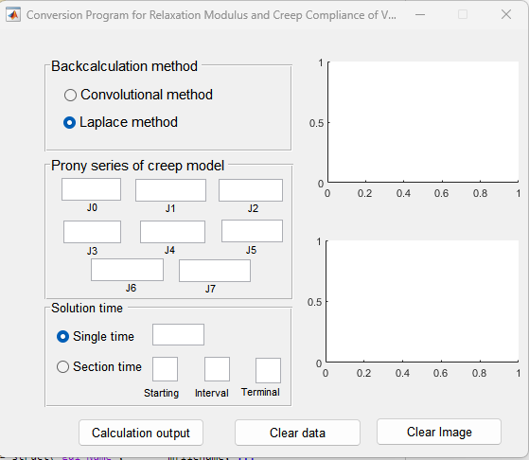

Figure 1 Software main interface

## 1 Backcalculation method

There are many methods for converting the relaxation modulus of viscoelastic materials to creep compliance, but this program uses two calculation methods: convolution method and Laplace method. One of the methods can be used arbitrarily. The convolutional method, due to its cumbersome calculation process and slow program operation, can cause stagnation. However, the Laplace method is theoretically difficult in depth, but the implementation process is simple and the running speed is fast. Therefore, it is recommended to use the Laplace method in actual calculations. Here is a brief introduction to the theoretical background of

the two methods.

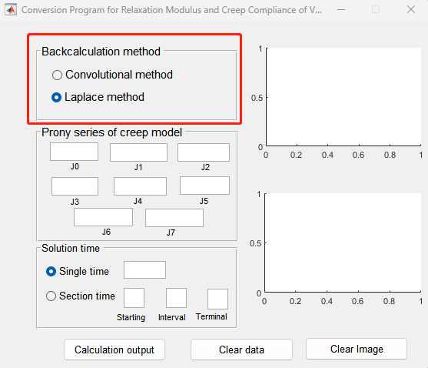

Figure 2 Backcalculation calculation method module

Mathematical relationship between creep compliance and relaxation modulus of viscoelastic materials in the time domain:

|  |  |  |
| --- | --- | --- |
|  |  | （1） |

Mathematical relationship between creep compliance and relaxation modulus of viscoelastic materials in the Laplace domain:

|  |  |  |
| --- | --- | --- |
|  |  | （2） |

**(1) Convolutional method**

The equation (1) is discretized into (3) as follows:

|  |  |  |
| --- | --- | --- |
|  |  | （3） |

When the interval length [*ti*-1, *ti*] is infinite, the integral interval  is a fixed value, and formula (3) can be written as:

|  |  |  |
| --- | --- | --- |
|  |  | （4） |

For the finite integral part in the formula, the integral method built-in in MATLAB is used for calculation

**(2) Laplace method**

The solving steps are as follows:

1) Using Prony level numbers to simulate the creep compliance of asphalt mixtures and determine model parameters;

2) Apply Laplace transform to the model and substitute it into (2) to obtain the Laplace domain relaxation modulus expression as shown in (5)

|  |  |  |
| --- | --- | --- |
|  |  | （5） |

Whereis relaxation modulus in time domain,  is relaxation modulus in Laplace domain,  is Laplace inverse transformation, s is Laplace operator.

3) Apply Laplace numerical inversion to (5) to obtain the time-domain solution of the relaxation modulus. Firstly, apply Laplace transform to the creep viscoelastic model, and the Laplace transform of the Prony series is as shown in (6) and (7).

|  |  |  |
| --- | --- | --- |
|  |  | （6） |

The relaxation modulus solution in the Laplace domain is as follows:

|  |  |  |
| --- | --- | --- |
|  |  | （7） |

After applying the Laplace inversion algorithm to equation (7), the time-domain solution of the relaxation modulus can be obtained.

The Laplace inversion algorithm can use the FT method, which is a high-precision inversion method proposed by J. Abate based on the Tablot method. The calculation formula is as follows:

|  |  |  |
| --- | --- | --- |
|  |  | (8) |
|  |  | (9) |
|  |  | (10) |
|  |  | (11) |
|  |  | (12) |

Where t is the calculation time, and r and M are parameters.

## 2 Prony series of creep model

Prony series is a commonly used creep model for viscoelastic materials, as shown in (13). It is a simple representation of the generalized Kelvin model or Maxwell model. Prony series is widely used by researchers due to its simplicity and ability to better characterize the delay performance of viscoelastic materials. It is also used in numerical calculation software ABAQUS. In this program, a 7-parameter Prony series model is used to fit the creep compliance test data using data analysis software such as Matlab, determine the model parameters, and then input them into this program.

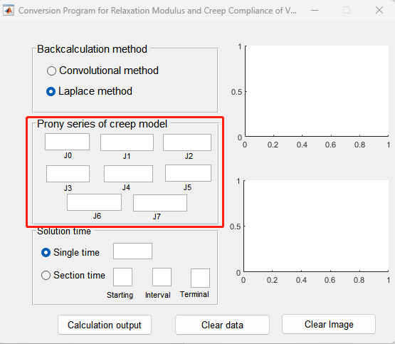

Figure 3 Prony creep compliance model module

|  |  |  |
| --- | --- | --- |
|  |  | (13) |

Where  is creep compliance (MPa-1), t is loading time (s),  is Creep compliance component (MPa-1),  is delay time (s).

## 3 Solution time

You can select a single time or section time according to the demand situation, where the section time needs to input the starting and ending times as well as the time step size.

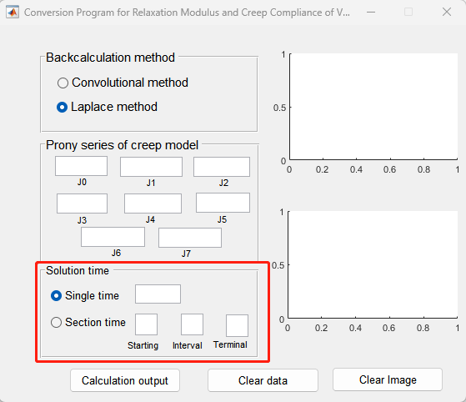

Figure 4 Solving time module

## 4 Calculate Analysis Button

## This section includes three buttons: calculation output, clear data, and clear images.

## Calculation output: Calculate the relaxation modulus value based on the backcalculation method, creep model, and solution time.

## Clear Data: Clears the input data of the software.

## Clear Image: Clears the image on the right.

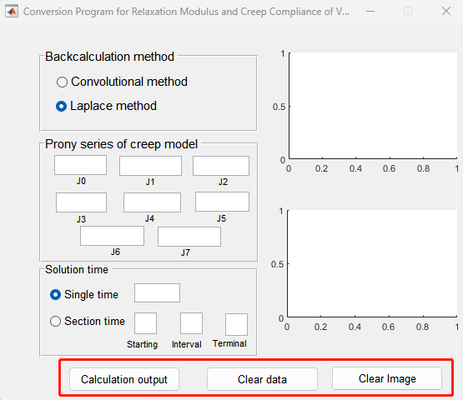

Figure 5 Calculation and analysis button module